Critical Thinking

Mitchell Duran
Colorado State University Global
MIS350: Information Systems Analysis and Design
Doctor Shawn Harrs
October 25, 2026

Student Registration System ERD
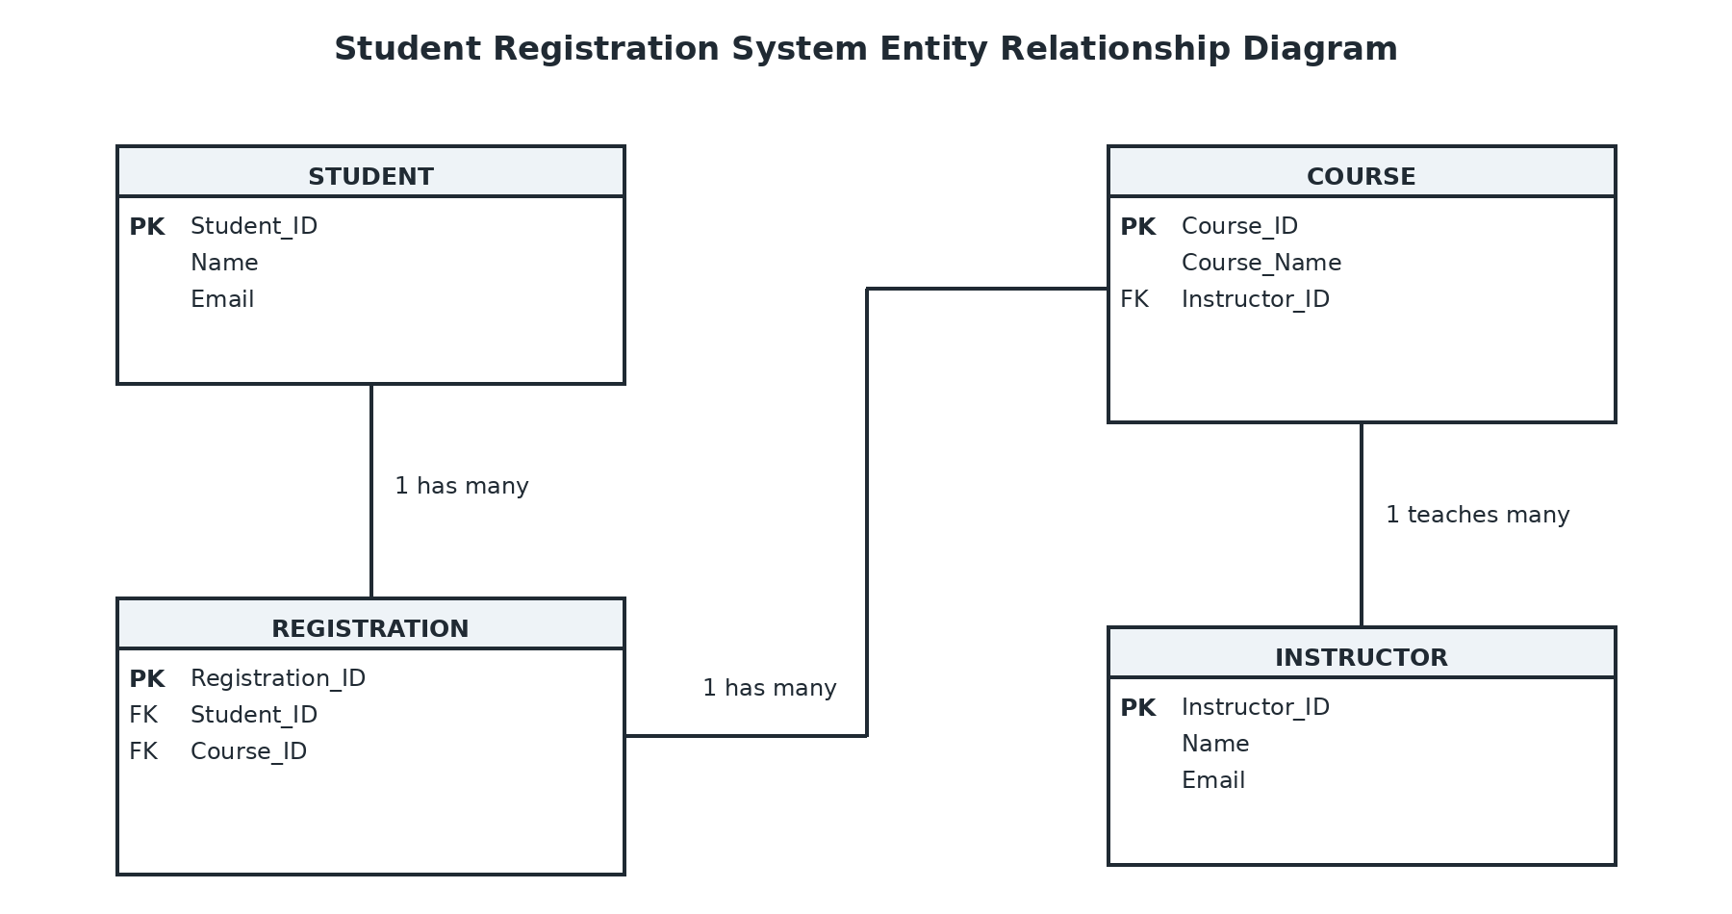
Figure 1 Student Registration System Entity Relationship Diagram

Description
This database stores students, courses, instructors, and registrations. The Registration entity connects each student to a course, while the instructor entity shows who teaches each course. Primary keys identify each record, and foreign keys connect the entities. This structure helps the school keep registration information accurate and organized.

